PUBLIC LANDS POSTCARDS

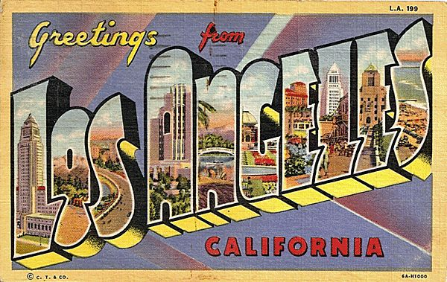
Congratulations! You have just been hired as an employee of the West Adams APES Tourism Company. Your first assignment is to create several postcards illustrating public lands. You will be making FOUR post cards. Make them look as realistic as possible.

Postcard #1: National Park

Postcard #2: National Forest

Postcard #3: (Choose 1) Wilderness Area, National Wildlife Refuge, Land Trust

Postcard #4: (Choose 1) World Heritage Site or Biosphere Reserve

For each post card, you must use a specific location. For example, you shouldn’t make a post card over generic “National Parks”, but rather “Yellowstone” or “The Grand Canyon”.

You must include the following for each post card:

Front:
- A hand-drawn photo of the park (it can be black & white or colored)
- The name of the park
- A slogan
- Location of the park

Back:
- The type of public land this park represents (at the top)
- A message on the post card (as if you are writing it to someone) that includes:
  - a very brief description of the history of the park
  - a description of the use of the land (logging, hunting, camping, hiking, mining, etc.)
  - sights to see
  - A recipient’s name and mailing address, a return address, and stamp (not a real one! be creative!)
PUBLIC LANDS POSTCARDS

Congratulations! You have just been hired as an employee of the West Adams APES Tourism Company. Your first assignment is to create several postcards illustrating public lands. You will be making FOUR post cards. Make them look as realistic as possible.

Postcard #1: National Park

Postcard #2: National Forest

Postcard #3: (Choose 1) Wilderness Area, National Wildlife Refuge, Land Trust

Postcard #4: (Choose 1) World Heritage Site or Biosphere Reserve

For each post card, you must use a specific location. For example, you shouldn’t make a post card over generic “National Parks”, but rather “Yellowstone” or “The Grand Canyon”.

You must include the following for each post card:

Front:
- A hand-drawn photo of the park (it can be black & white or colored)
- The name of the park
- A slogan
- Location of the park

Back:
- The type of public land this park represents (at the top)
- A message on the post card (as if you are writing it to someone) that includes:
  - a very brief description of the history of the park
  - a description of the use of the land (logging, hunting, camping, hiking, mining, etc.)
  - sights to see
  - A recipient’s name and mailing address, a return address, and stamp (not a real one! be creative!)

