Ecocolumn Lab
Days 1 and 2 Building the Ecocolumn

Materials for Building the Bottles
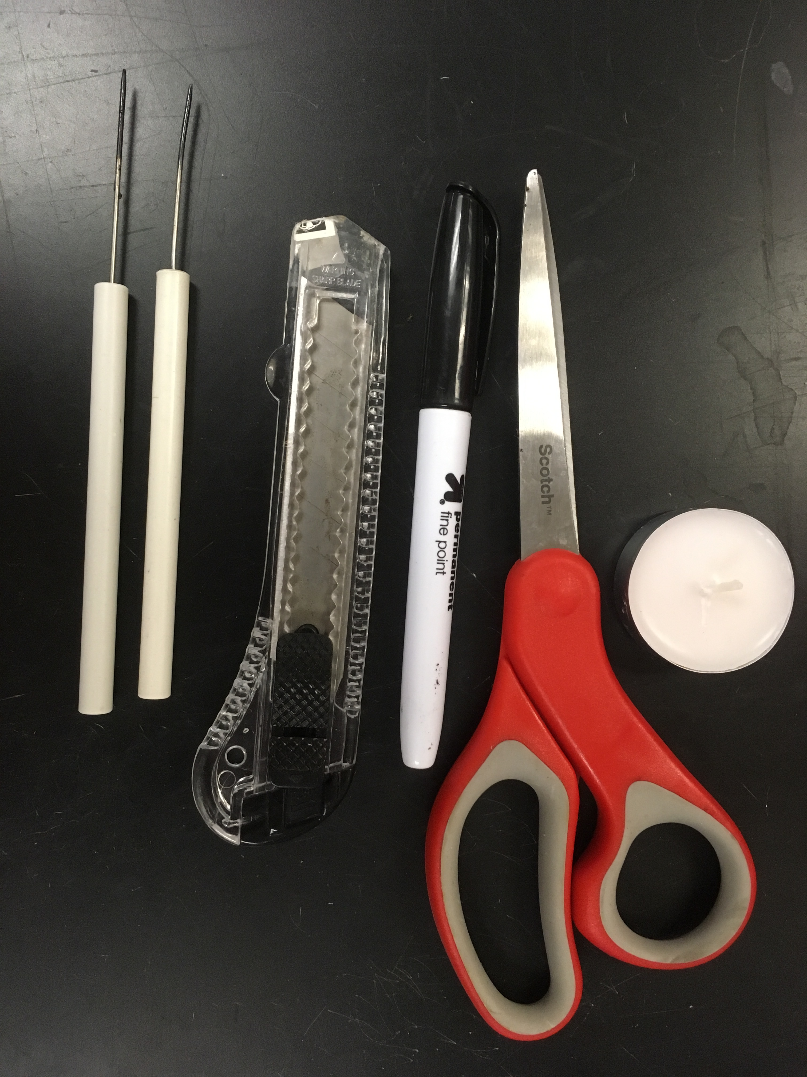
Three 1-gallon square clear plastic water bottles (brought by students)
2 bottle caps from the bottles (brought by students)
Dissecting needle
Tea candle Potting Soil
Scissors Sand
Box Cutter Gravel
Seeds 500 ml Plastic Beakers

Procedure
Divide up tasks to Persons 1,2,3 and 4 in your group. All persons should work at the same time on their tasks.

Persons #1 and #2:
- Remove labels and handles from bottles. If donating unopened water, pour into buckets to save until needed in 2 weeks for aquatic chamber.
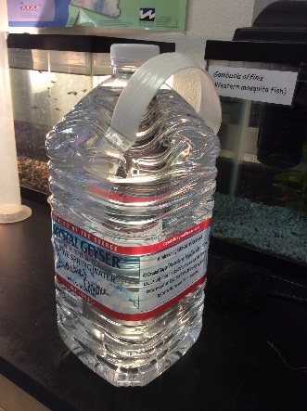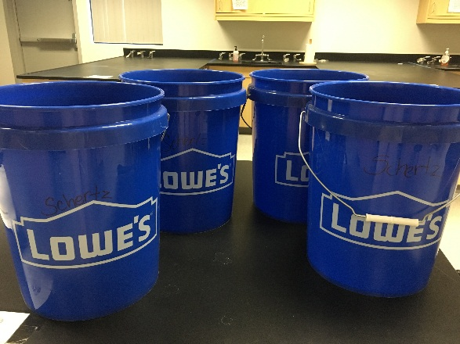
- Use a razor blade and then scissors to cut your bottles to look like this. Maximize length on each bottle.

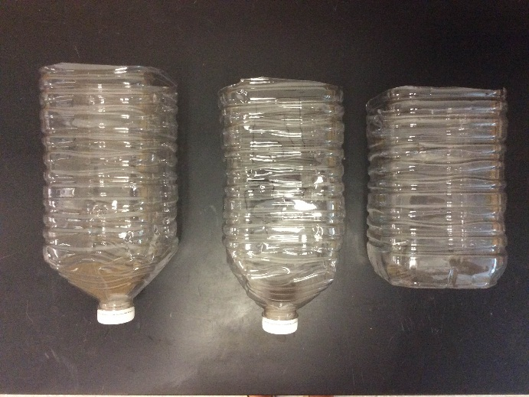

- Cut 2 flaps on alternate sides of your aquatic chamber to allow for air flow through the chamber-one on either side of the chamber. Cut the flaps 3 cm square and about 5 cm from the top so that water won’t leak out. Your water level will be about halfway up the bottle.
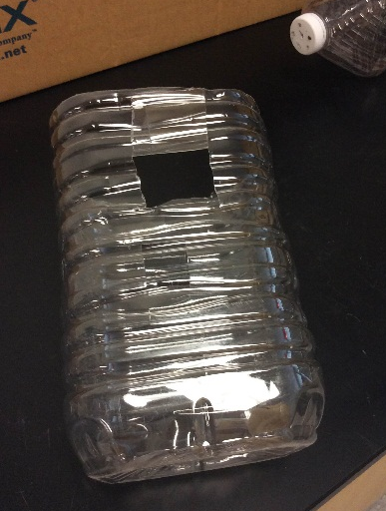

- Assemble your bottles to make sure they nest into one another like this. If they do not nest sturdily, carefully cut the bottle so that a ridge on a bottom bottle goes outward instead of inward.
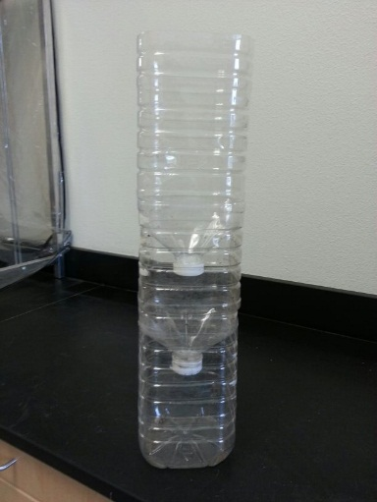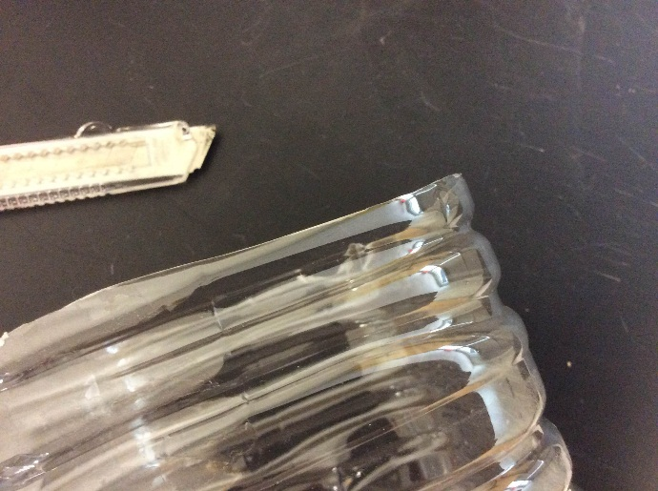

Now wait for persons #3 and #4 to finish the lids before continuing.

Persons #3 and #4 Tasks:

- Use a tea candle and a dissection probe to poke holes in 2 lids. Each person should work on different lid.
  - Heat up the tip of the probe with the candle and then melt holes with the probe. You need about 10 holes per lid.
  - For the lid on the bottom of the terrestrial (soil) chamber, the holes need to be larger so silt doesn’t clog them—about 3 mm in diameter. Use a ruler to measure—VERY IMPORTANT
  - For the lid on the bottom of the filter (sand) chamber, the holes need to be smaller so sand doesn’t fall out—about 1 mm in diameter. Use a ruler to measure—VERY IMPORTANT

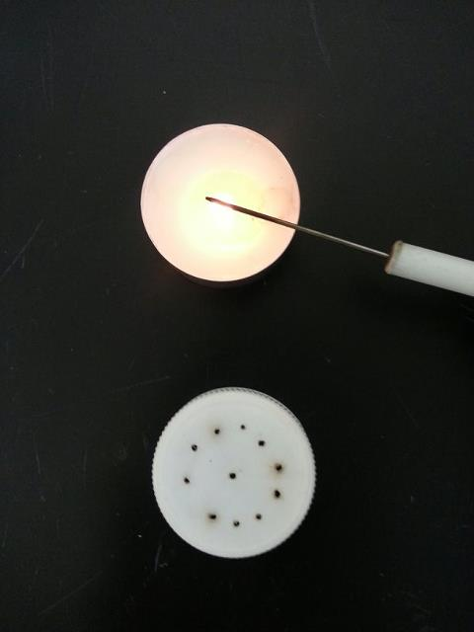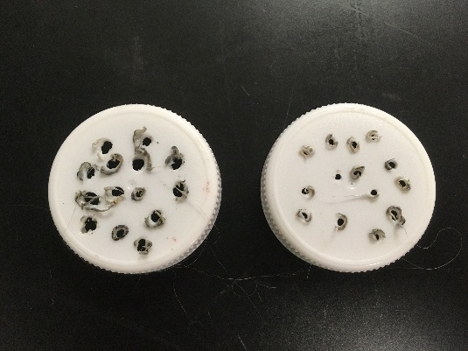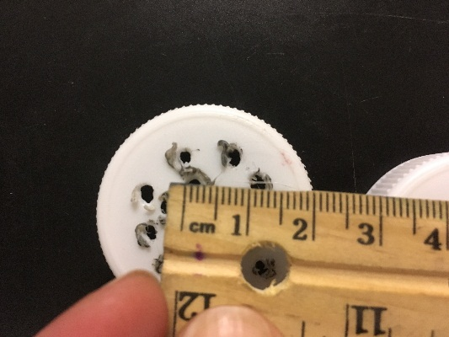

When Finished with these lids, give to Persons #1 and #2 and continue below:

- Make a Sprinkler. Take one of your cut off bottoms from the bottle that’s about 2-4 cm. tall. Use the candle and dissection probe to poke 15-20 holes in it. Make sure you spread out the holes to the corners and make sure you make them about 1mm so that water can drip through. Set aside, you will need this on day 2.

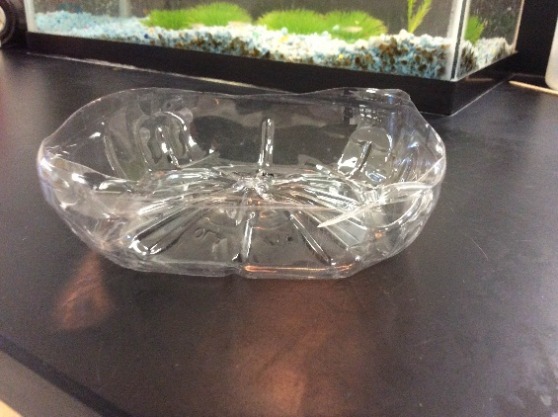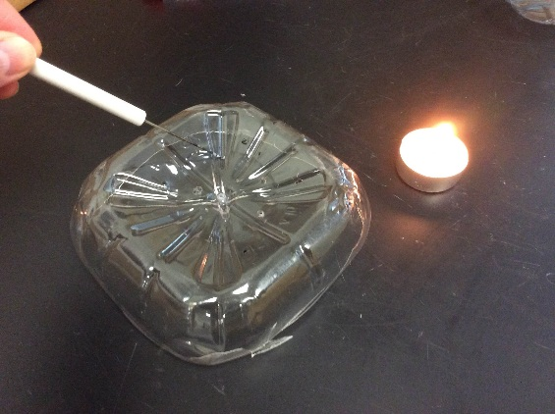

Persons #1 and #2 Tasks after receiving the lids with holes.

- Fill your top bottle (terrestrial chamber)
  - Place 3-4 centimeters of clean gravel in the bottom to promote proper drainage. Measure from the lid up. Rinse the gravel in a collander to clean before using.
  - Fill with potting soil up to about halfway up the bottle.
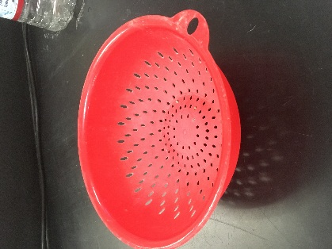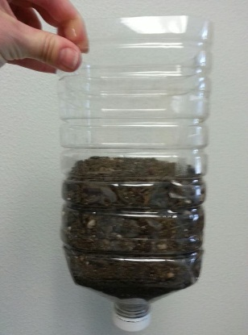

  - Pour water into the chamber, place over a large plastic beaker and check to make sure it drains properly. Add more potting soil as water will compact the soil and lower the level.
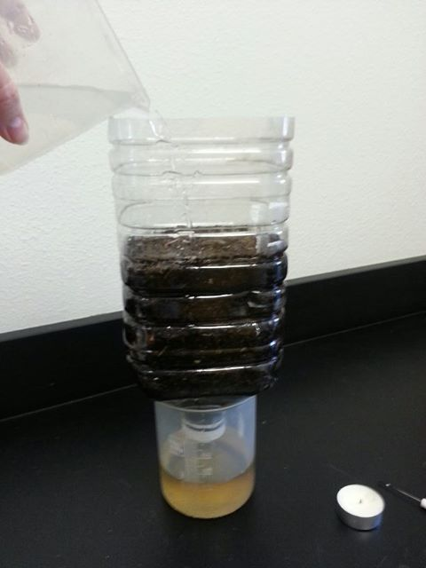
  - Drain 3-4 times with tap water. Often, an eco-column will drain properly the first couple of times, then clogs with silt.

Unclogging your Ecocolumn
If your terrestrial chamber clogs with silt, carefully unscrew the lid so that you relieve the pressure without taking the lid off completely. The water should drain out. After it drains, set the chamber on its side and carefully take off the lid. Try to keep as much gravel in your ecocolumn as you can. Rinse the lid with water to clear the silt and then make your holes larger using the candle and dissection probe. Make sure your holes are 3 mm each in the lid.

  - Replace the lid and check the drainage several times again. If it clogs again, repeat the previous step.

- Fill your middle chamber (filter chamber) with
  - About 2-3 cm of clean gravel on bottom. Measure from the lid up. Rinse the gravel in a colander to clean before using.
  - About 7-8 cm of sand on top of the gravel. Measure from the top of the gravel up.
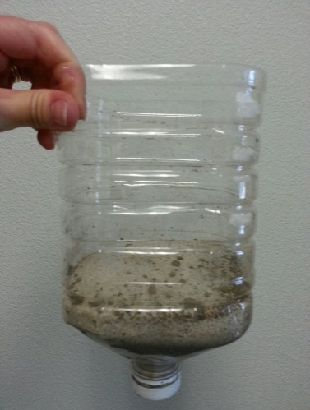
  - Drain 2-3 times the same way you did the terrestrial chamber.

Drain, Drain, Drain, Drain, Drain, Drain, Drain, Drain---the more your drain, the cleaner your water becomes.

- When you have drained each chamber separately several times into a beaker, reassemble your eco-column like this.
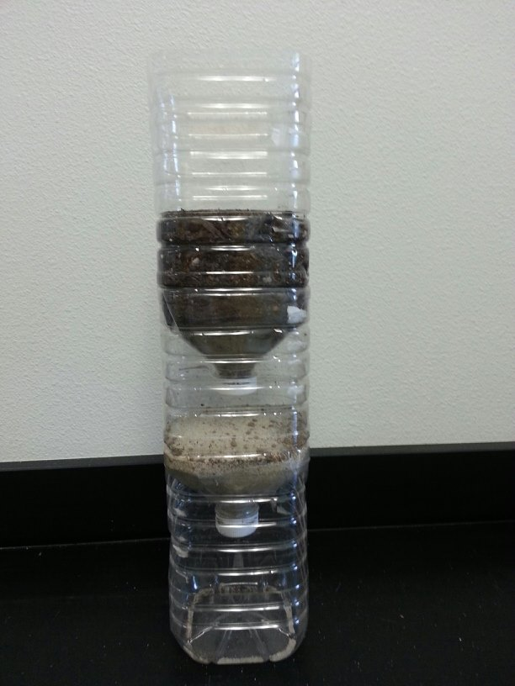

- Fill the eco-column with tap water and let drain through all the chambers to the bottom overnight. With a sharpie, label your ecocolumn with your group and period (make it small). Do not put your label on the Sprinkler as you will discard the sprinkler in about a week.
- Place the Sprinkler that persons #3 and #4 have made on top of the ecocolumn.

Building the Ecocolumn
Day 2

Persons #1 and #2
- Separate the 3 chambers. Place the terrestrial chamber and filter chamber on top of plastic beakers.
- Drain the terrestrial and filter chambers separately into large beakers several times.
- Check for clogs and unclog if necessary—refer to yesterday’s directions for how to unclog. The filter (sand) chamber will drain very slowly—this is normal.
- When all chambers are draining properly, take soil measurements: (Fertility #, Fertility level, pH, Temperature) using the soil probe. Record data on spreadsheet. Follow the directions for the Rapitest Soil Probe carefully.

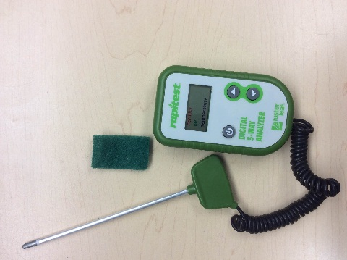

- Plant seeds in your terrestrial chamber.
  - With a sharpie, label the corners of your terrestrial chamber with 1,2,3,4. Label a 5 in the middle of one of the sides.
  - Make 5 small holes in your soil 1 cm deep. One in each corner and one in the middle.
  - Add 2 legume seeds and 3 other seeds of your choice. ONE seed per hole.
  - Gently cover the holes and seeds with soil.
  - Record in which corner you planted which seed on your spreadsheet.

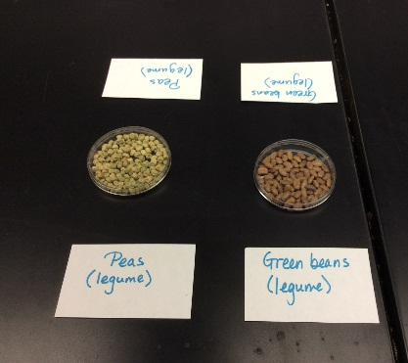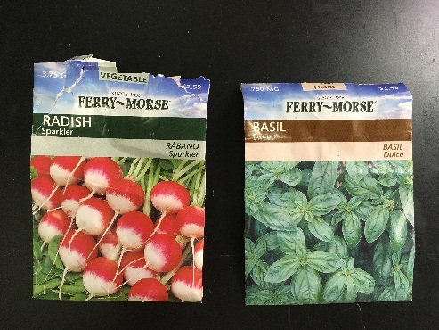

- Assemble your column and place the sprinkler you made in step #5 on top. Fill with water and allow it to sprinkle your terrestrial chamber. Let drain overnight.

Persons #3 and #4
Create a spreadsheet. One person in your group will create the spreadsheet on Google sheets and share the spreadsheet with everyone in your group and also with me: kschertz@hartdistrict.org
- I will periodically check your spreadsheet for a lab grade to make sure it is filled in correctly for a grade.
- You must take turns filling in the spreadsheet on data collection days.
- You need the following information in your spreadsheet. You will add to it weekly for about 2 months.

Sample Spreadsheet: (This example has two rows due to lack of space on this paper, but you need to create one big row with all the headings)

Day | Date | Soil pH | Soil Fertility # | Soil Fertility Level | Soil Temperature (C ) | Plant #1 height cm | Plant #2 height cm | Plant #3 height cm | Plant #4 height cm | Plant #5 height cm
1 | Sept. 2, 2015 |  |  |  |  | 0 | 0 | 0 | 0 | 0
2

Water Dissolved Oxygen (mg/l) | Water pH | Water Temperature (C) | Water Nitrite (ppm) | Water Nitrate (ppm) | Observations (several sentences) | Adjustments | Person Recording Data (must alternate)

  - Person recording data: your group must rotate this task
  - Include units on the top row ONLY! Not in the individual cells
  - If we do NOT take data for that item, leave it blank—do not say “none”
  - Observations need DETAIL!
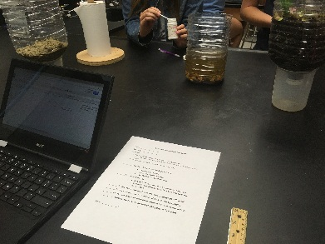
On a daily basis, empty your aquatic chamber and fill up the top sprinkler. Not only are you keeping your terrestrial chamber moist, but you are continuing to drain your eco-column.

Ecocolumn Lab
Adding Detritivores (about 1 week later)
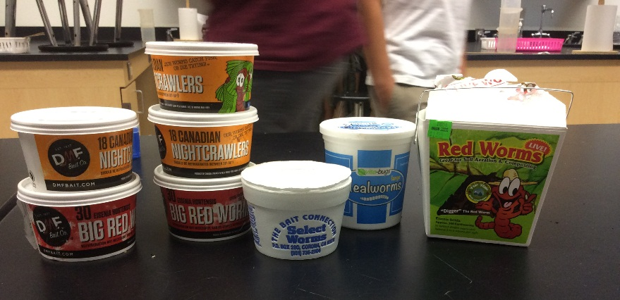

Materials
2-3 Worms (can be purchased from a bait store or dug from a garden)

2-3 other insects such as pillbugs, pinscher bugs, beetles. Must be detritivores, not herbivores nor carnivores.

- Students will bring in these items
- Find some leaves from the schoolyard, tear up and place on top of your soil—this is called “leaf litter”.
- Add your detritivores.
- Take data on soil and plants and add to data chart
- Keep flushing your ecocolumn by adding a little bit of water at a time. Make sure that you do not create a flood that will drown your insects.

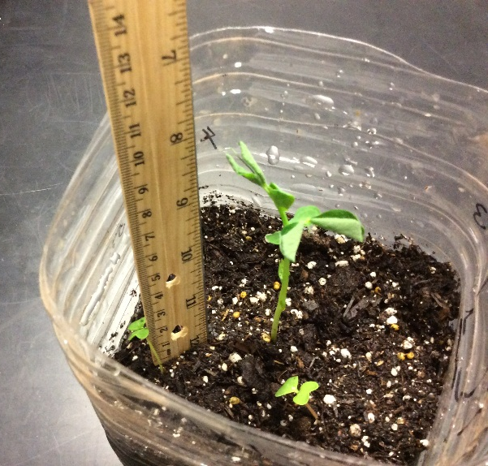

Ecocolumn Lab
Building the Aquatic Chamber (about 1 week later)
When the water drains clear or almost clear, it is time to set up your aquatic chamber. This should take about 2 weeks from your initial build.
Materials
Gravel
Approximately 1 ½- 2 Liters of distilled or purified water.
Elodea or other aquatic plant (you can buy your own or use a provided elodea)
Dissolved Oxygen Probe
Temperature Probe
pH Probe
Nitrate Test Strips
- Empty the dirty water from your bottom (aquatic) chamber into the sink.
- Fill your aquatic chamber with about 2 cm of gravel. Rinse with tap water in your collander to clean it. This is very important as gravel is typically dirty and you don’t want to dirty your water.
- Fill with 800-1000 ml of spring or distilled water.
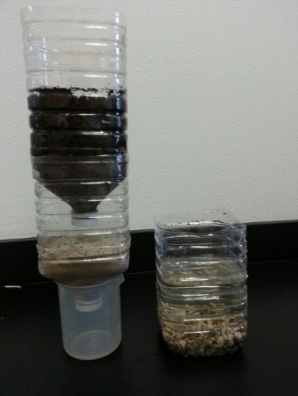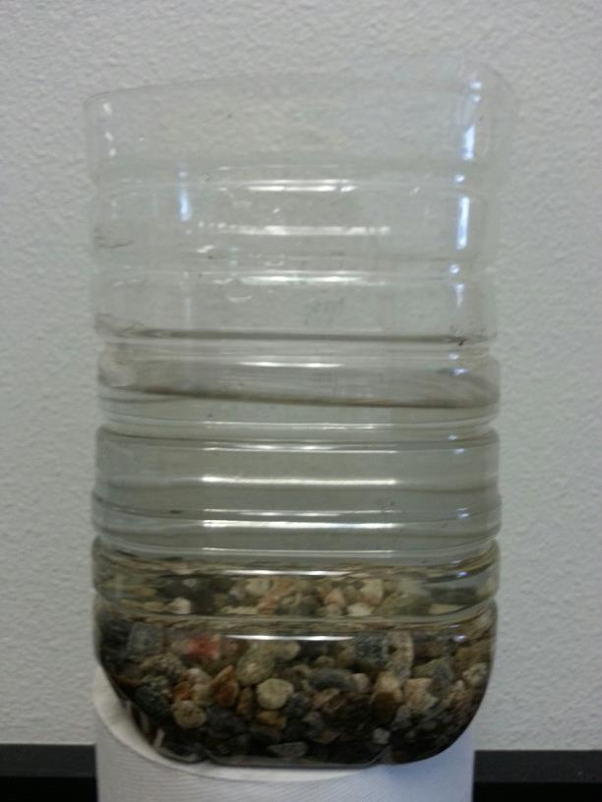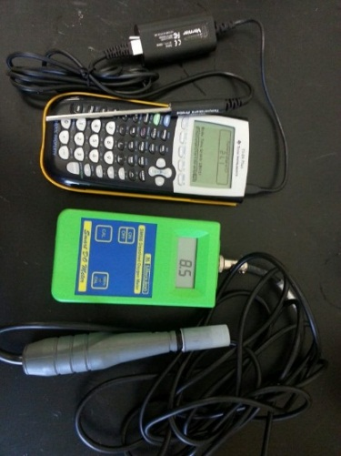

- Take water quality readings. Follow the directions for each test carefully. Make sure you ALWAYS record units!
  - Temperature in cm (the temperature will be room temperature, but if this was a stream, or other body of water, the temperature is very important, because dissolved oxygen concentration is dependent on temperature)
  - Dissolved oxygen in mg/l
  - pH (no unit)
  - Nitrite/Nitrates. Today, we will take one collective nitrite/nitrate reading for the distilled/stream water and use it for all the groups’ data since the water comes from one source. This saves us money as the strips cost $20/bottle. Everyone’s eco-column will be different after today, so you will take readings of your own water later.
- After your water quality readings, take an elodea plant, measure it in cm and record your data. Then place in the water.
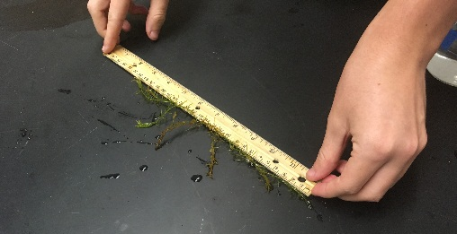
- Take soil and plant measurements.
- Reassemble your column and water with tap water just a little bit from the top. From this point, you only want to water just enough to moisten the soil and drip a VERY SMALL amount into the aquatic chamber. This helps keep the water clean, but allows some particles to drip through which is important for the aquatic ecosystem.
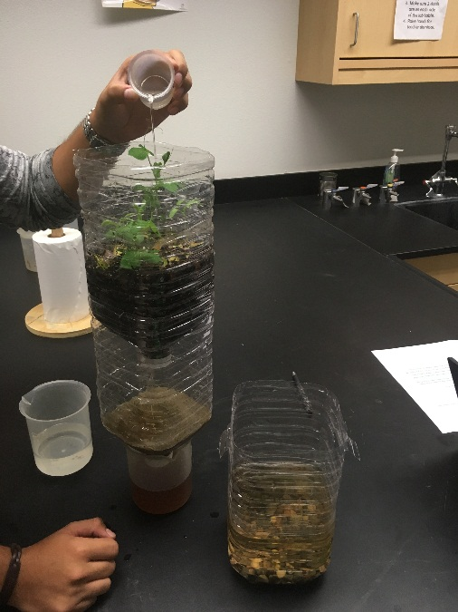

Ecocolumn Lab
Adding a Fish (about 2 days later)
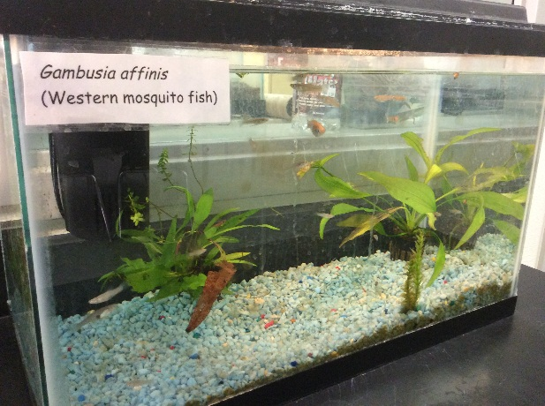
- Take water quality readings and record data.
- Add ONE mosquito fish (I will provide) OR 1 to 2 guppies (you will provide).
  - Take your aquatic chamber over to my fish tank and use a net to add ONE fish.
Your eco-column can only handle 1 fish or MAYBE 2 mosquito fish or guppies before it runs out of dissolved oxygen and/or nitrates from fish waste get too high.
- Take other data and record on spreadsheet
For the next several weeks
- Take data readings about once a week. Make sure you save all your data.
- If your fish dies, bury it in the terrestrial chamber. Wait a few days until your dissovled oxygen readings are higher than 3 mg/l and then add a new fish.

